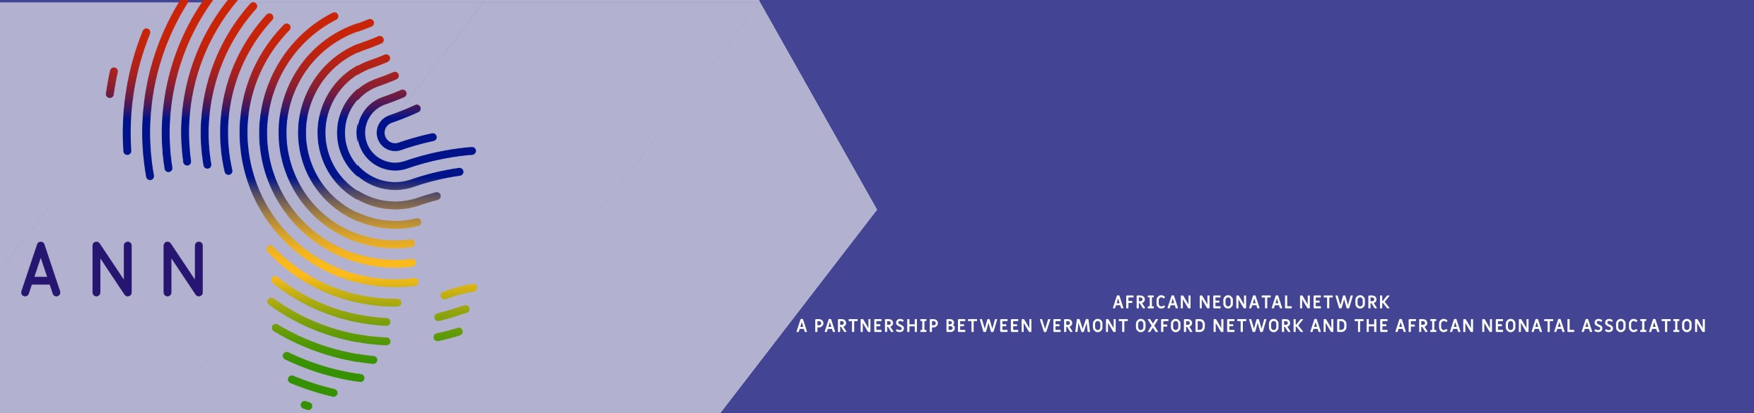

Hopis

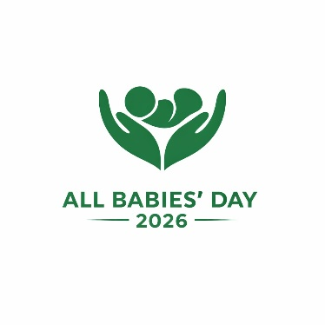 ‘Small Beginnings, Strong Future’

African Neonatal Network
Kacyiru Sector
Kamatamu Cell, Rwanzovu
KG620 St, House ST9
Kigali
Rwanda

MOH Address

Dear Mr/Mrs /DR X

Re All Babies Day Celebrations 01 June 2026 in all ANN member units in X country
,
The African Neonatal Network is proud to be celebrating our very first All Babies’ Day on 01 June 2026. This day will be celebrated throughout all 27 African Neonatal Network-member units across 10 African countries. It is a continent-wide movement that has been made possible by collaboration between the African Neonatal Network (ANN), The African Neonatal Association (ANA), The Vermont Oxford Network (VON) and the Gates Foundation. Together we are championing newborn survival across Africa through data, collaboration, and quality improvement. We are active in Zimbabwe, Zambia, Mozambique, Botswana, Nigeria, Uganda, Ethiopia, Rwanda, Kenya, Ghana, with plans to spread further afield and to increase our reach.
This significant day in our calendar exists to celebrate all babies and bring together some of our babies’ parents, the hospital Quality Improvement(QI) teams, any partner organisations, hospital management and Ministries of

Health. To date the African Neonatal Network hospital units have cared for over 3000 babies. These are only some of the babies we are celebrating on ABD. We are proud that our data driven quality improvement focus has enabled us to reduce neonatal mortality across the Network- saving over 892 lives thus far.
We plan to have a gathering in each of our A.N.N. hospitals (spear-headed by DR X, the national lead of Y country). This will be followed by a celebration! In the afternoon, we will have a virtual gathering on Zoom, where the ANN principal investigator, Dr Alex Stevenson will be giving a presentation on the A.N.N. as well as showing how other countries have celebrated their ABD across the continent. We would be honored if you were able to attend this online meeting as well and will share the invitation soon.
We gratefully request your endorsement and support of what we believe is a worthwhile cause

Sincerely,

Dr A.G. Stevenson, Principal Investigator African Neonatal Network.

